DESCRIPTION

Use Jenkins to deploy Java Application to Tomcat Apache

**Description:**

While developing a highly scalable application, real challenges come into picture during the deployment of that application into production or real time data scenarios. One of the biggest drawbacks for any product after development is having the application stuck while working in normal case scenarios in a real time production environment.

Your organization is adopting modern DevOps processes to automate deployment on Tomcat Apache using Jenkins CI/CD pipelines.

Jenkins’s pipeline using Groovy DSL language makes easy to integrate build, test and deployment stages within single pipeline. Considering this as urgent requirement, organization is focusing on automating build and deployment on Tomcat Apache. Pipeline should be designed in such a way that it would be triggered automatically without any developer’s interaction.

**Tools required:** Git, GitHub, Jenkins, Tomcat Apache and Maven

**Expected Deliverables:**

* Configure Maven Build on Build Server for automating builds.
* Integrate Maven build tool and then perform test cases execution and deployment on Tomcat Apache.

Steps to perform:

1. 2 AWS EC2 instances are used to perform the above activities.
   1. Jenkins host
   2. Application host – Deploy the application.
2. GitHub is used as source repository.
3. Jenkins’s pipeline used to build, test and deploy the application on docker container,
4. GitHub webhook is used to automate the build deployment once the code is checked in.
5. Jenkins’s plugin has installed – like, Git, Maven, Docker.

GIT hub Link

***https://github.com/mailyathish/spring-petclinic.***

Jenkin’s – Plugin

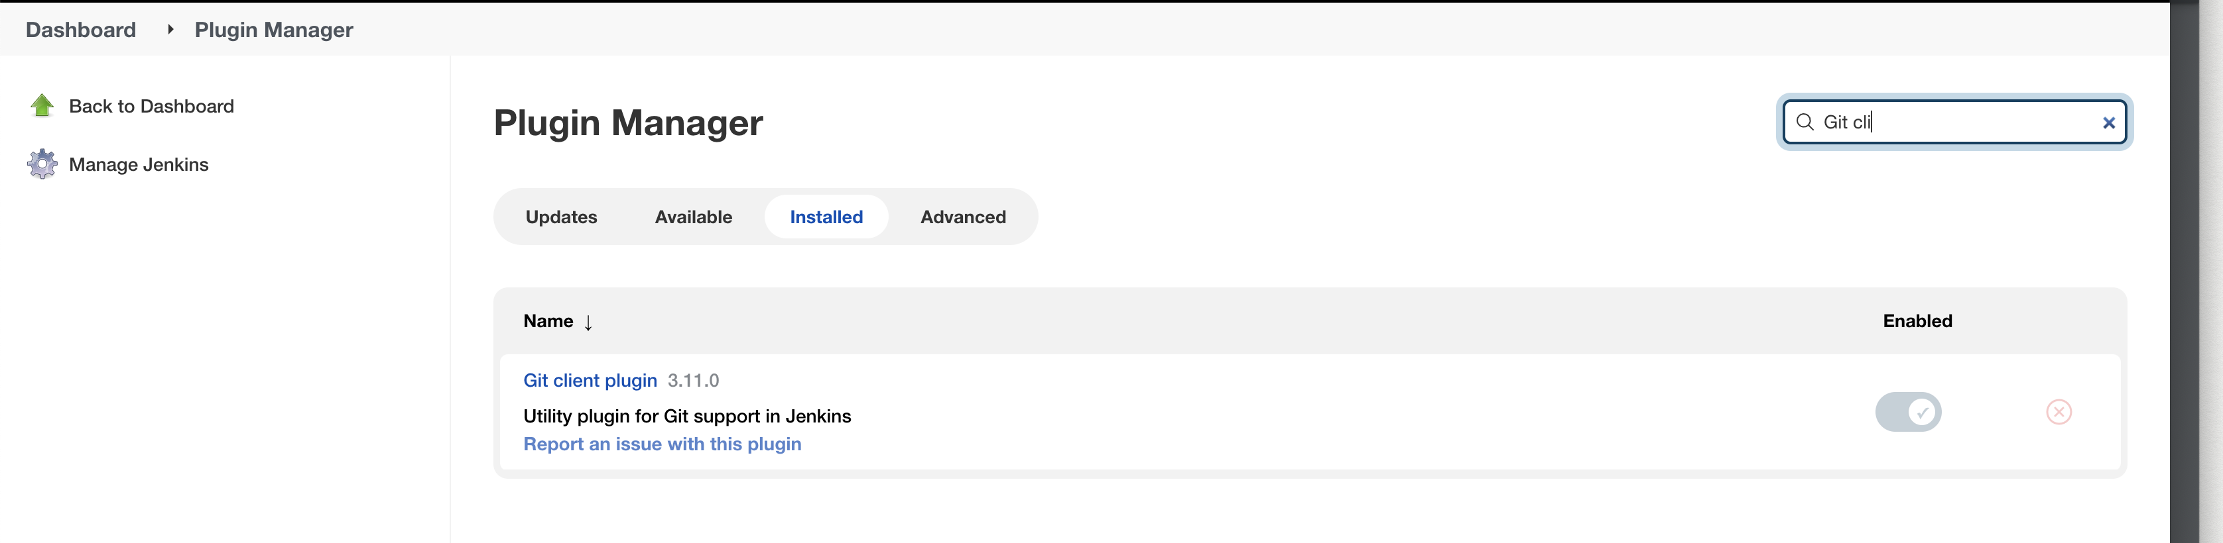

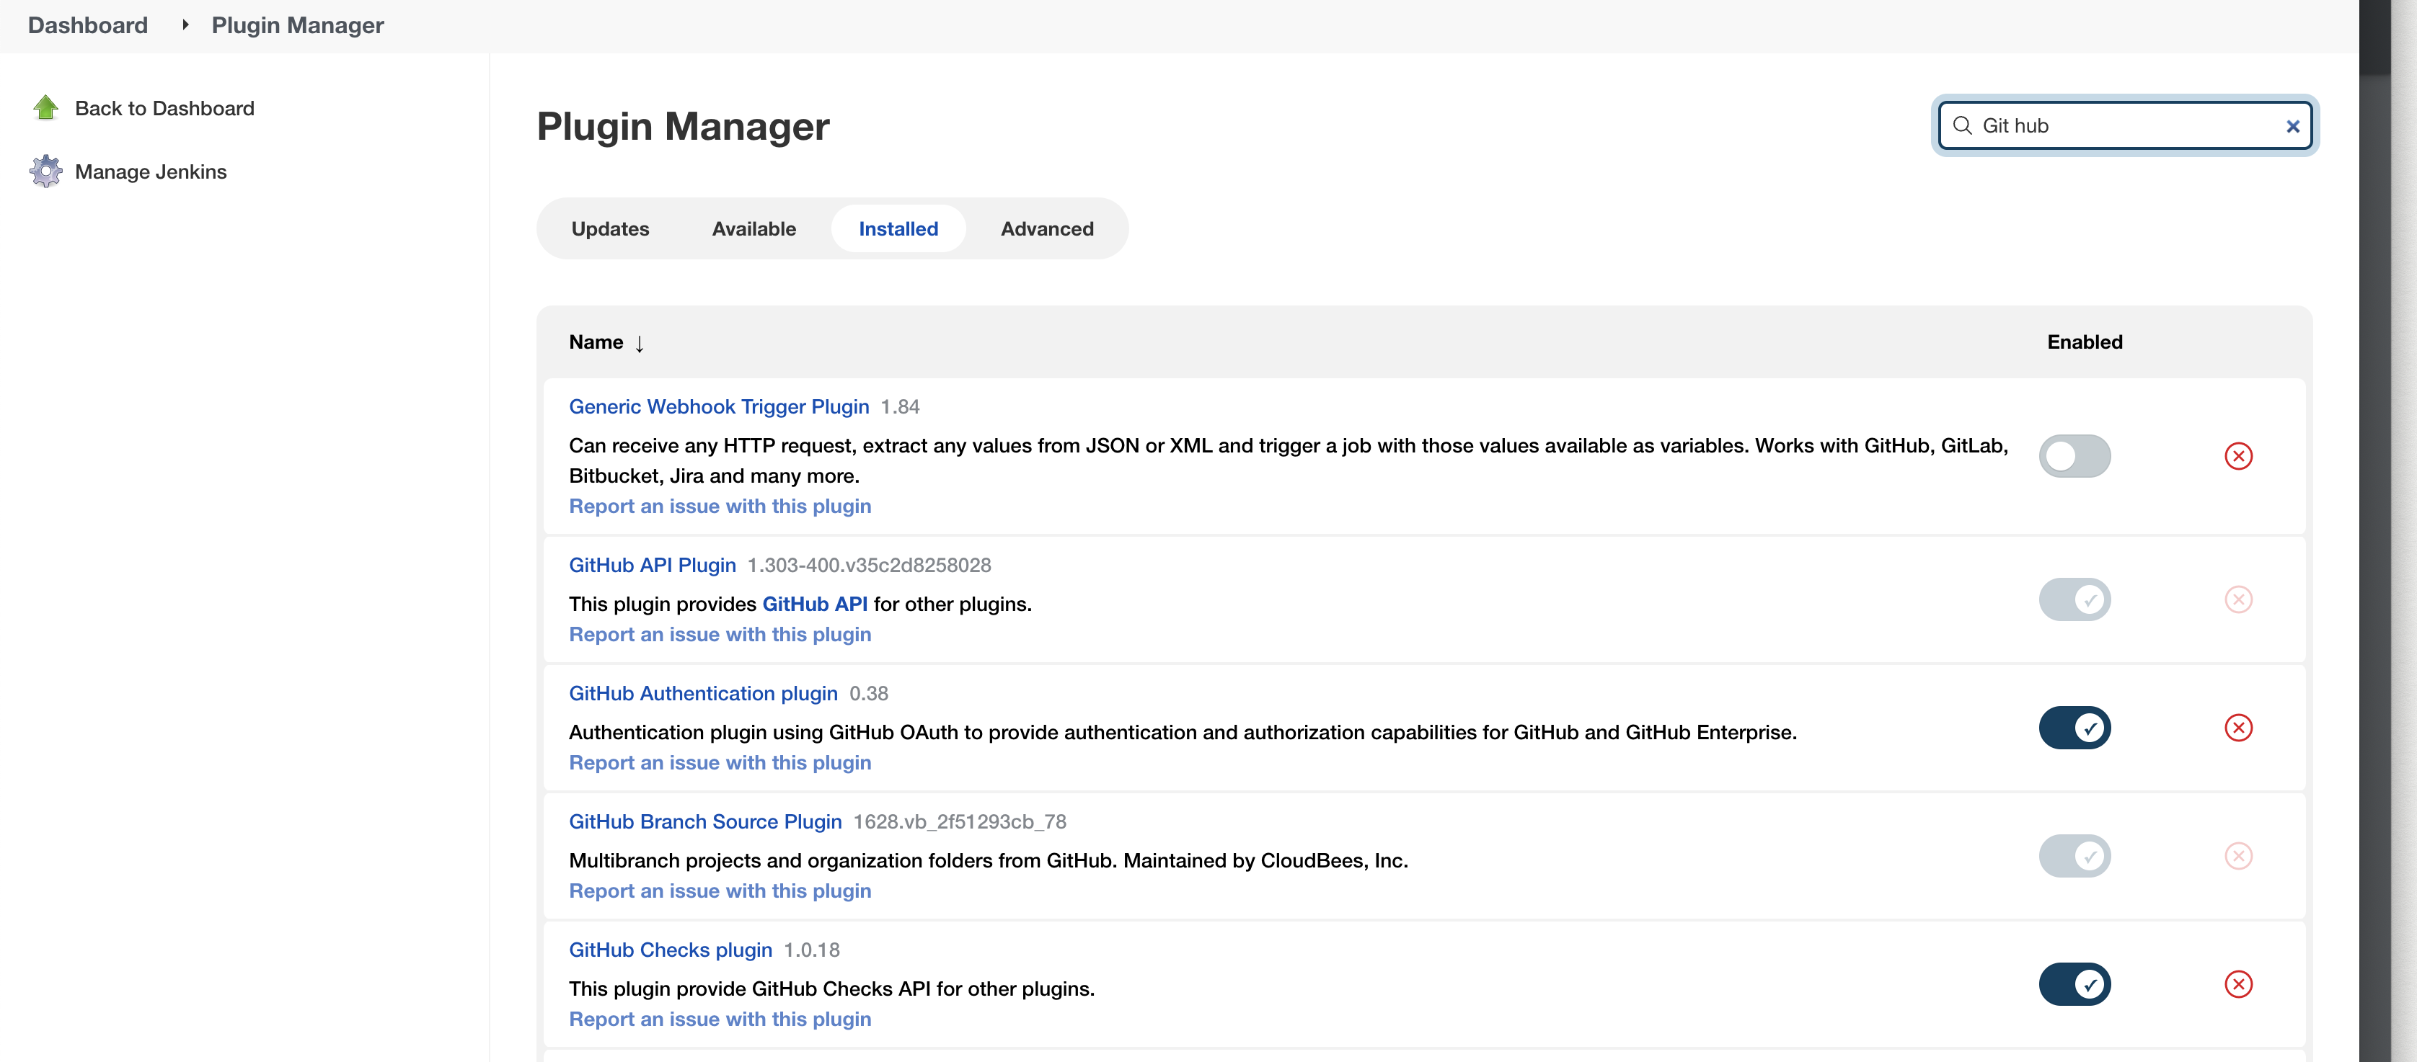

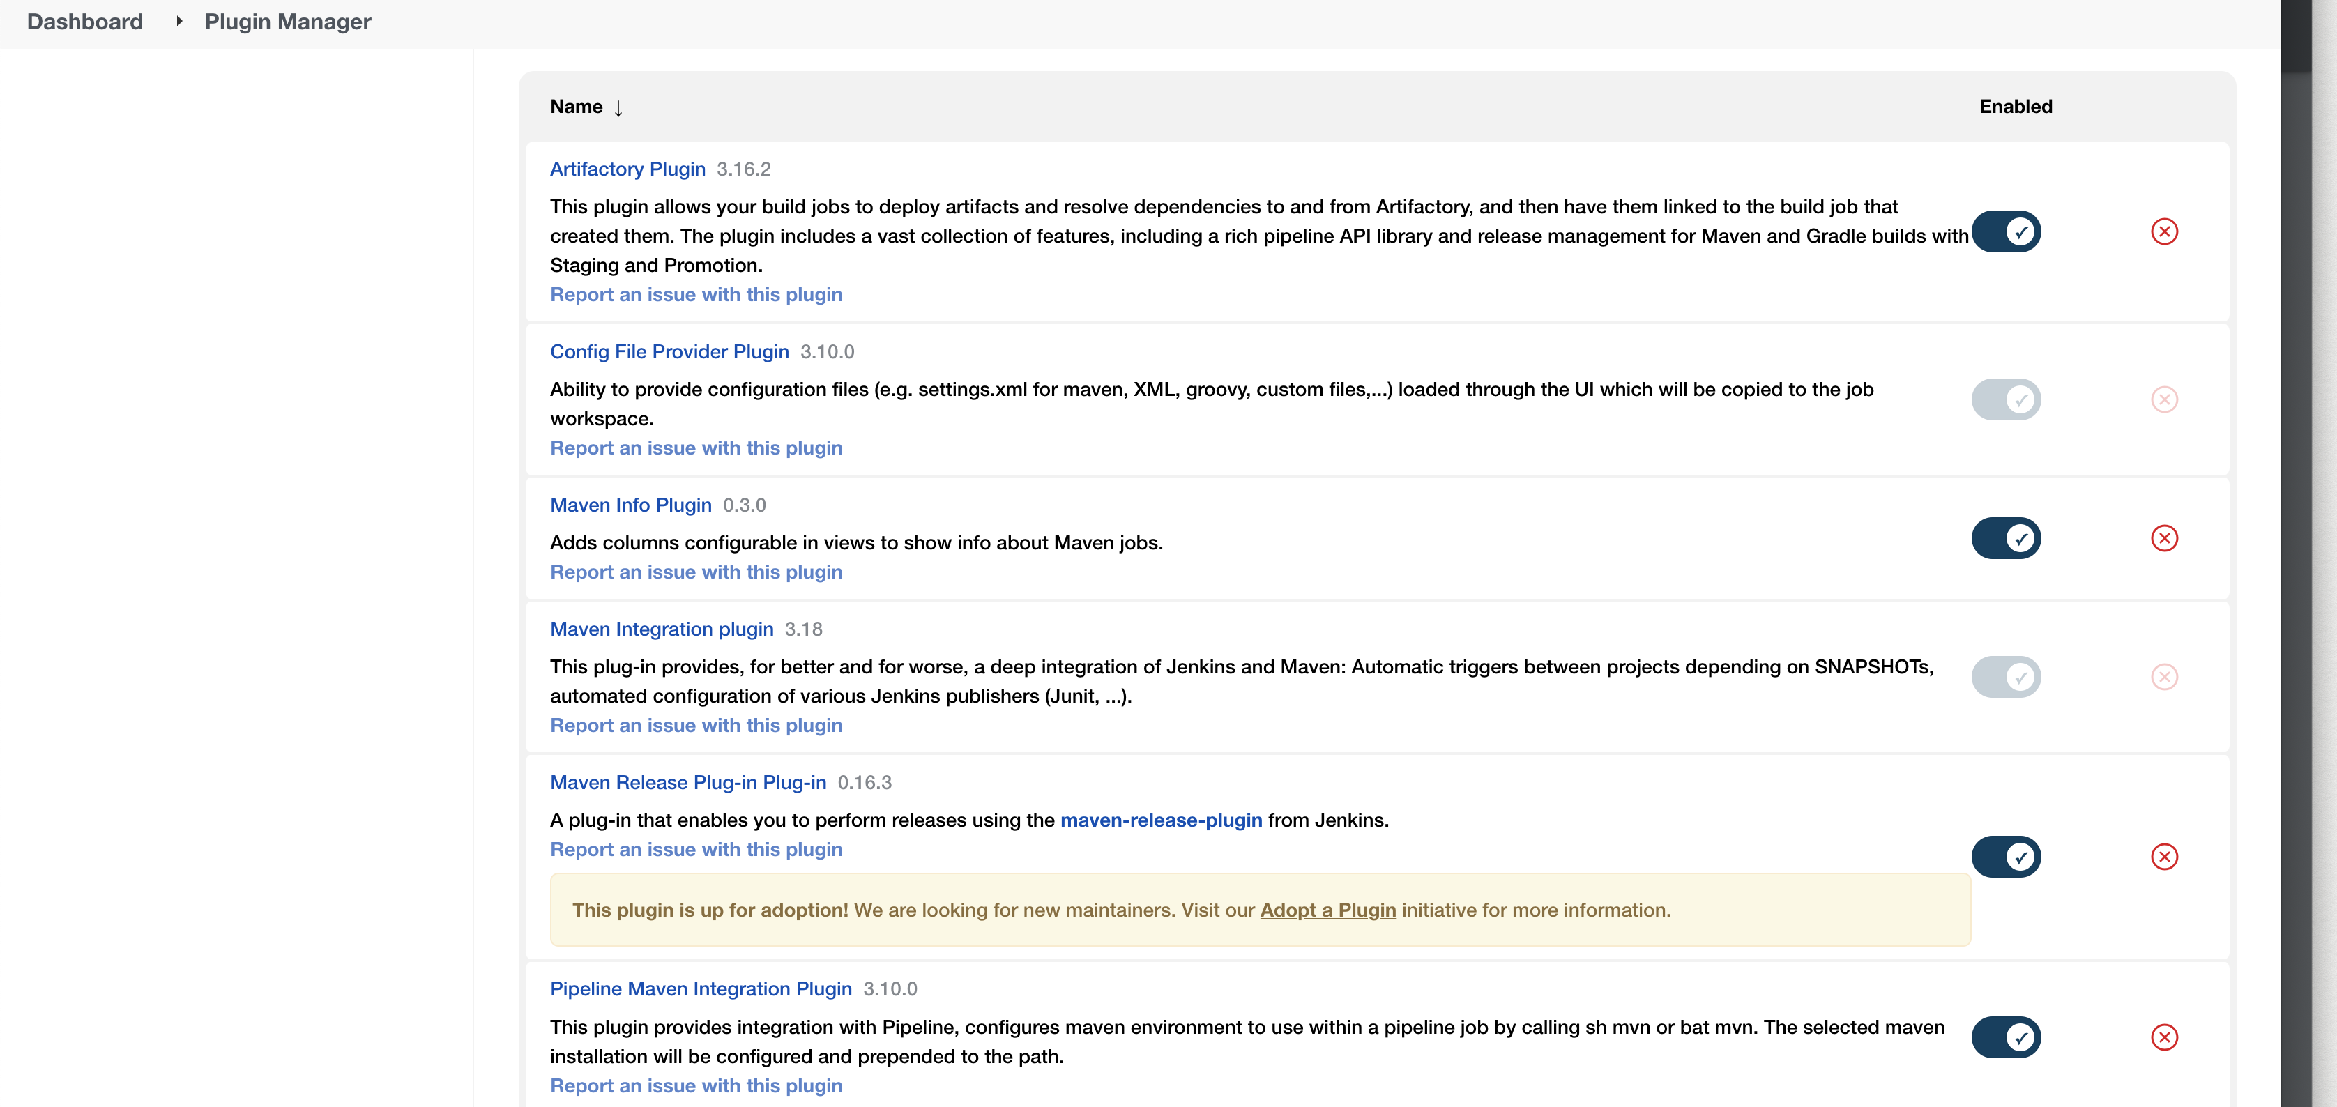

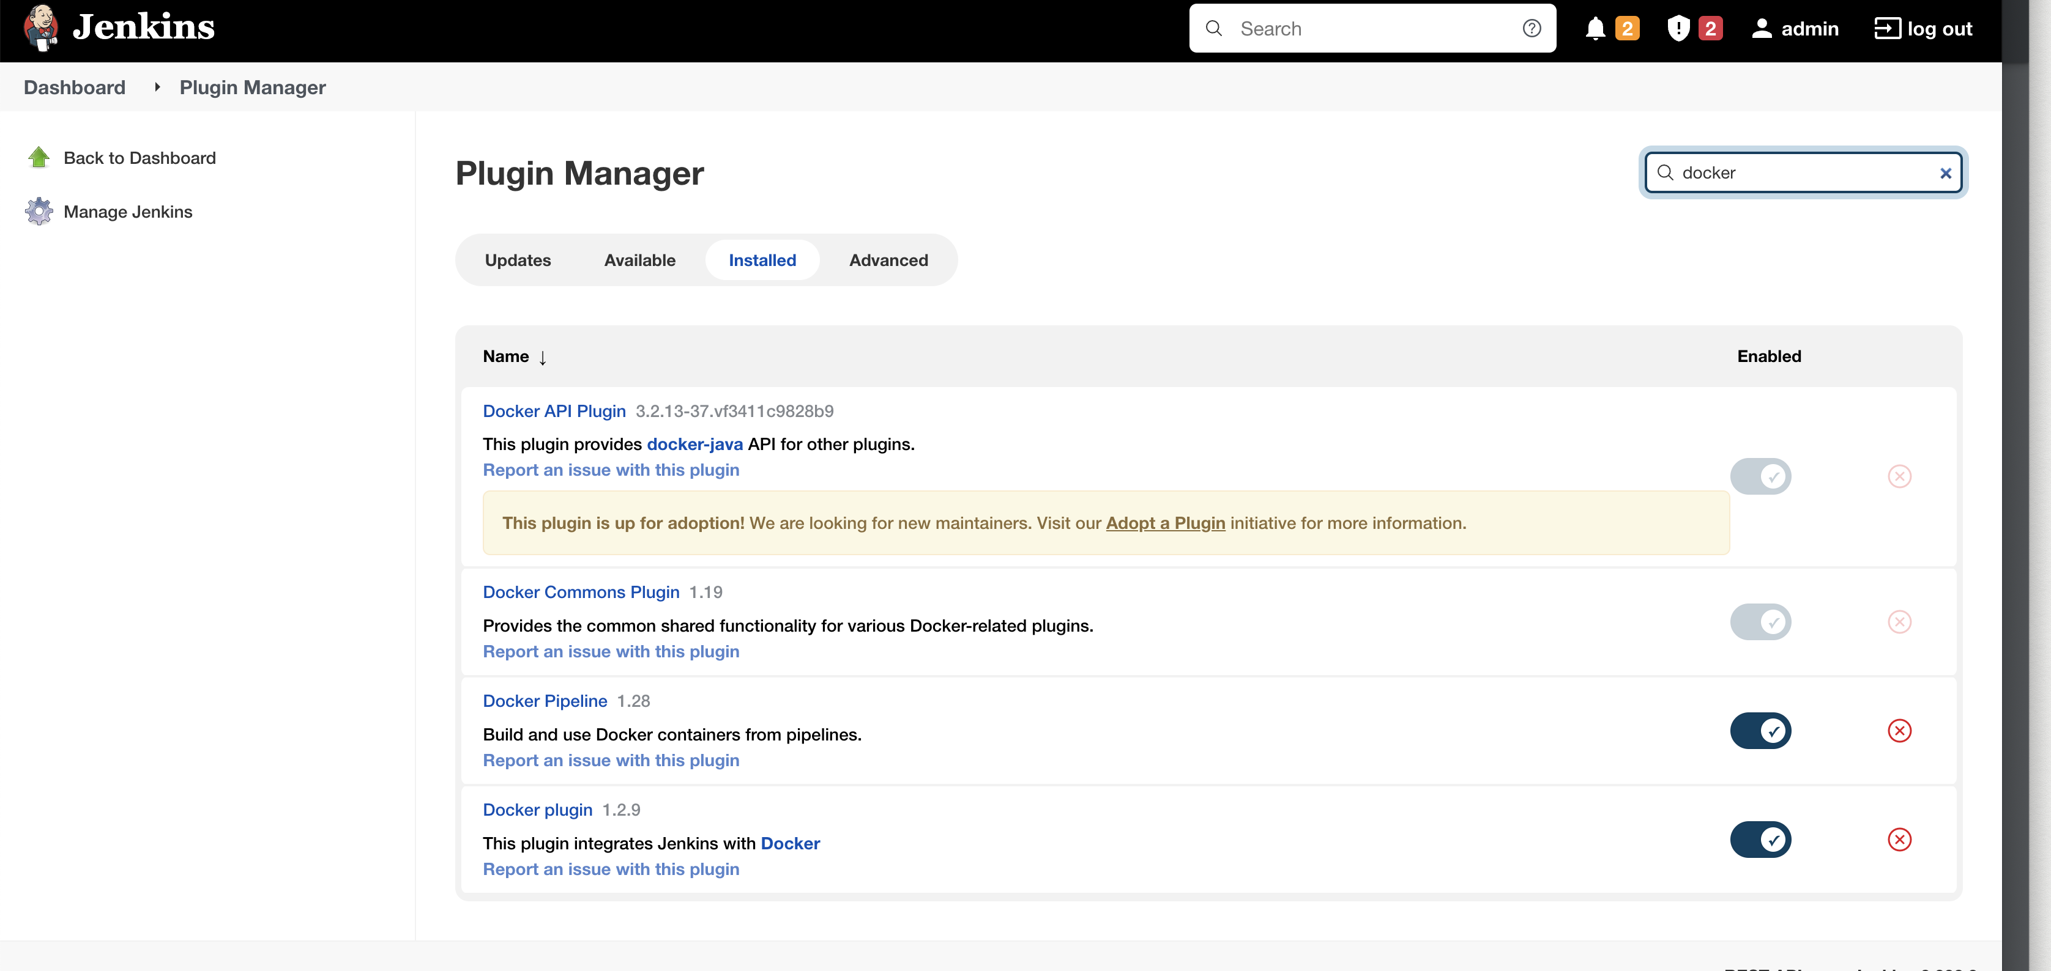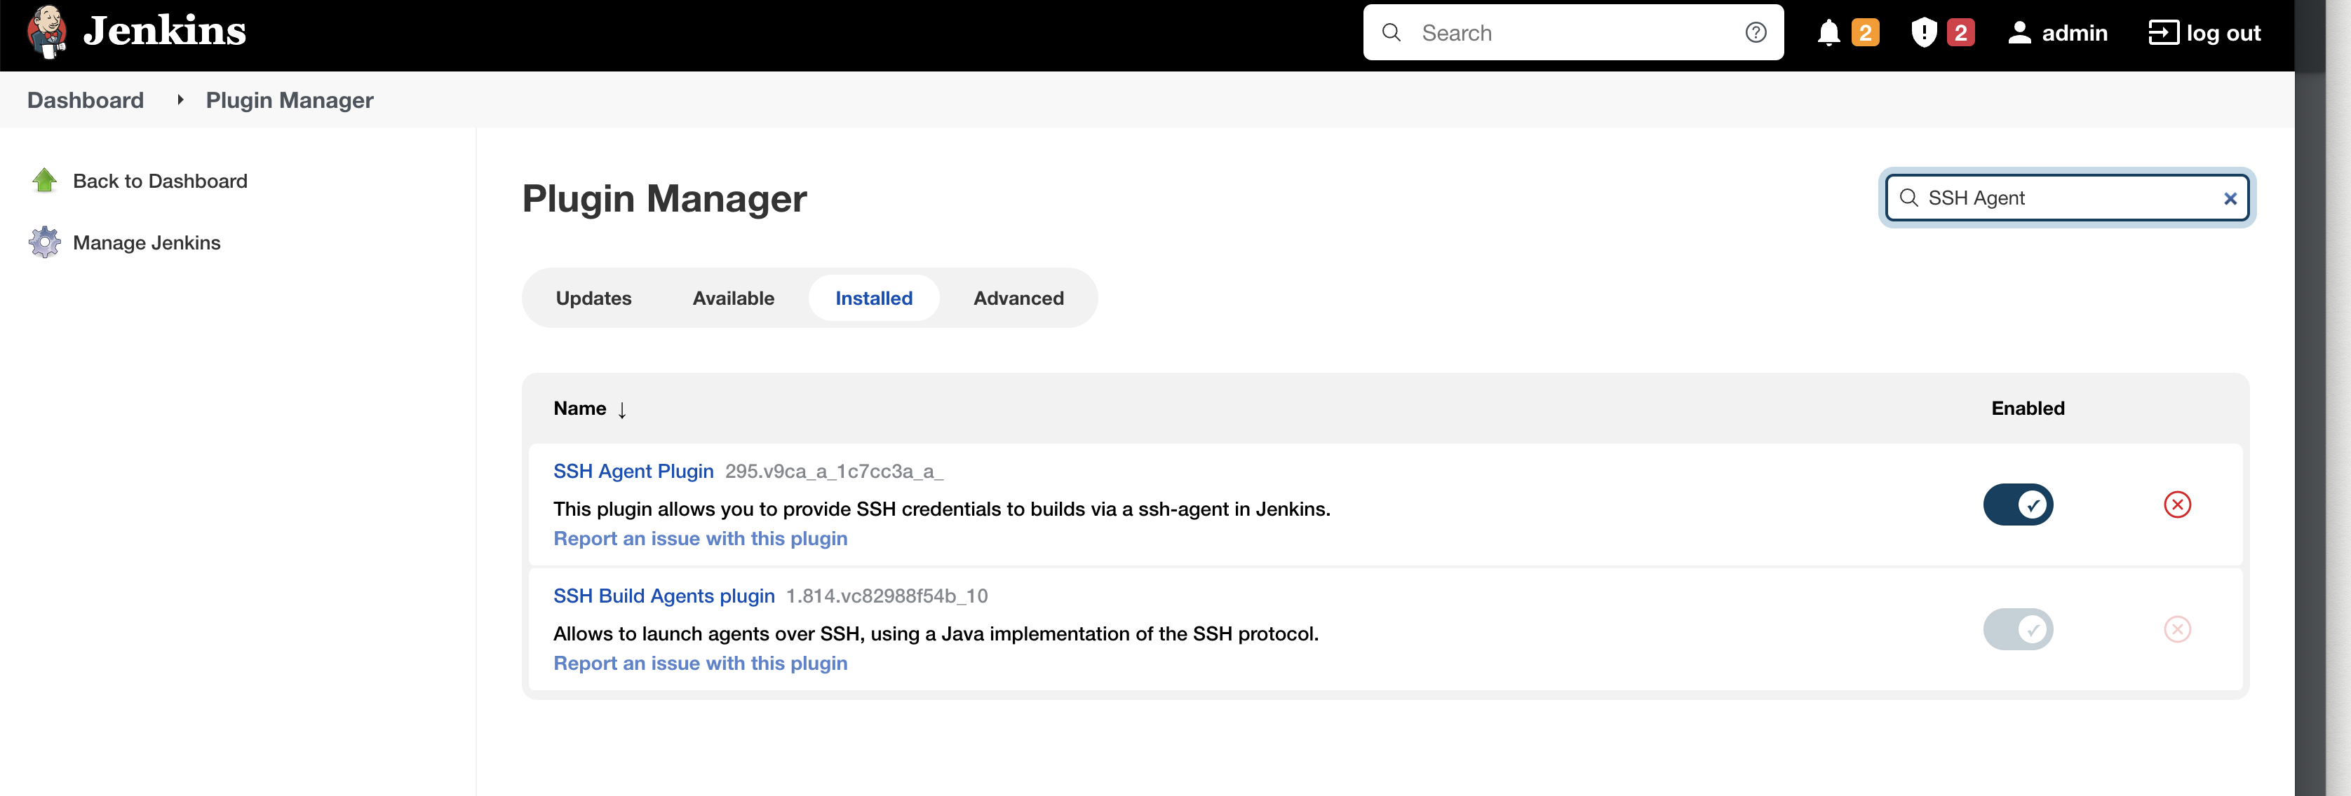

Credentials used

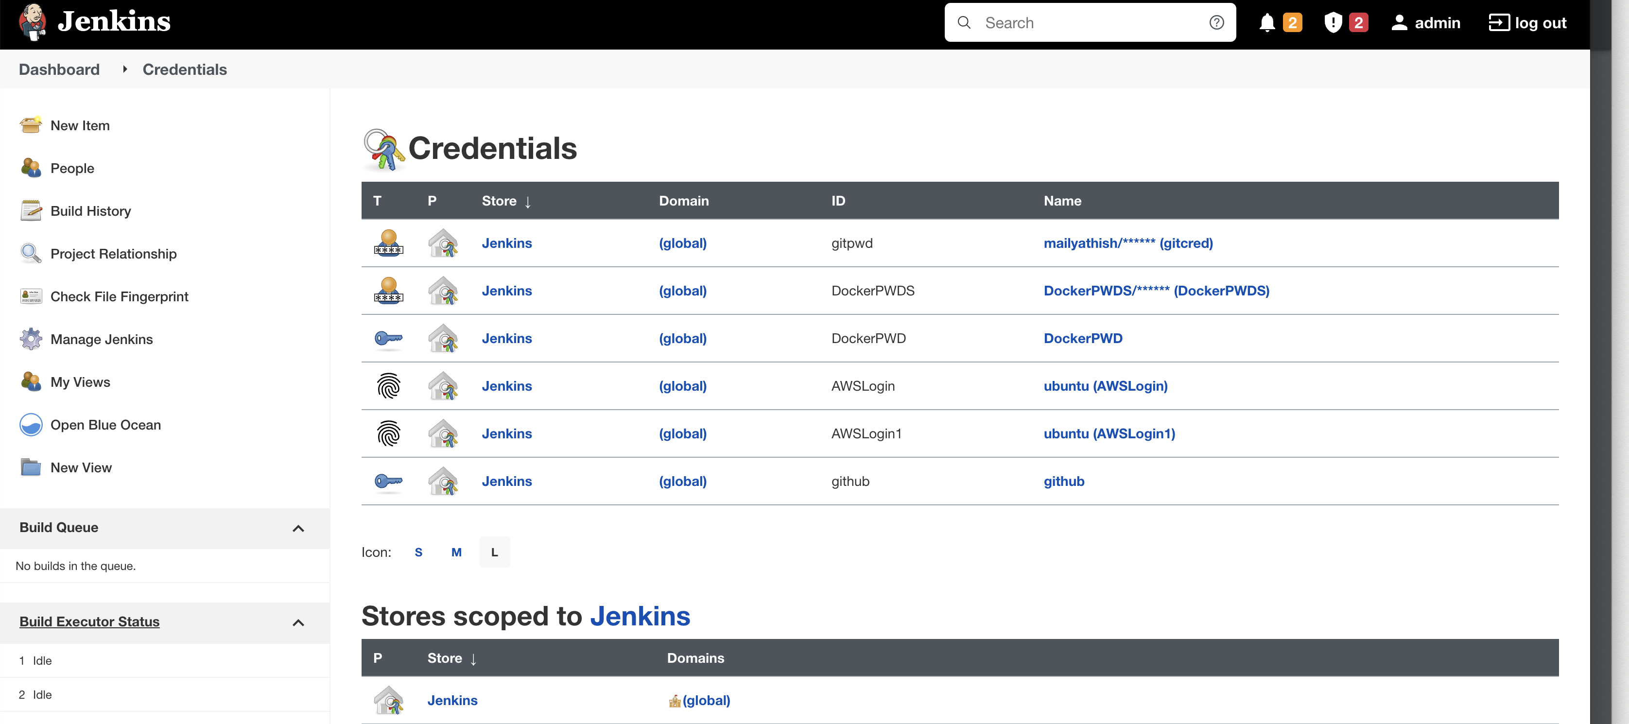

*Pipeline – script*

pipeline {

agent any

environment {

DOCKER_RUN = 'docker run -p 8080:8080 -d --name my-app rajuyathi/petclinic:latest'

}

tools

{

maven "maven"

}

stages {

// GIT checkout

stage('checkout') {

steps {

git credentialsId: 'gitpwd', url: 'https://github.com/mailyathish/spring-petclinic.git'

//git branch: 'master', url: 'https://github.com/mailyathish/spring-petclinic.git'

}

}

// Maven build

stage('Build Application') {

steps {

echo '=== Building Petclinic Application ==='

sh 'mvn -B -DskipTests clean package'

}

}

// Maven Junit - Test

stage('Test Application') {

steps {

echo '=== Testing Petclinic Application ==='

sh 'mvn test'

}

post {

always {

junit 'target/surefire-reports/*.xml'

}

}

}

// Performance test using JMeter

stage('Performance Test') {

steps {

sh 'mvn verify'

}

}

// Docker Build

stage('Docker Build and Tag') {

steps {

sh 'docker build -t rajuyathi/petclinic:latest .'

}

}

// Pushing the Docker image to Docker Hub

stage('Push Docker Image'){

steps {

withCredentials([string(credentialsId: 'DockerPWD', variable: 'DockerPass')]) {

// some block

sh 'docker login -u rajuyathi -p ${DockerPass}'

sh 'docker push rajuyathi/petclinic:latest'

}

}

}

// Running the Container on Remote AWS - Instance.

stage('Run Container on Dev Server'){

steps {

sshagent(credentials: ['AWSLogin1'], ignoreMissing: true){

// sh 'docker run -p 9090:9090 -d --name my-app rajuyathi/petclinic-spinnaker-jenkins'

sh "ssh -o StrictHostKeyChecking=no -l ubuntu 54.197.169.41 docker rm -f my-app || true"

sh "ssh -o StrictHostKeyChecking=no -l ubuntu 54.197.169.41 ${DOCKER_RUN}"

}

}

}

}

}

Docker file

From tomcat:8.0.51-jre8-alpine

RUN rm -rf /usr/local/tomcat/webapps/*

COPY ./target/*.war /usr/local/tomcat/webapps/ROOT.war

CMD ["catalina.sh","run"]

## Git Webhook

## Jenkins’s Stage View

## Jenkins’s output

## Maven build

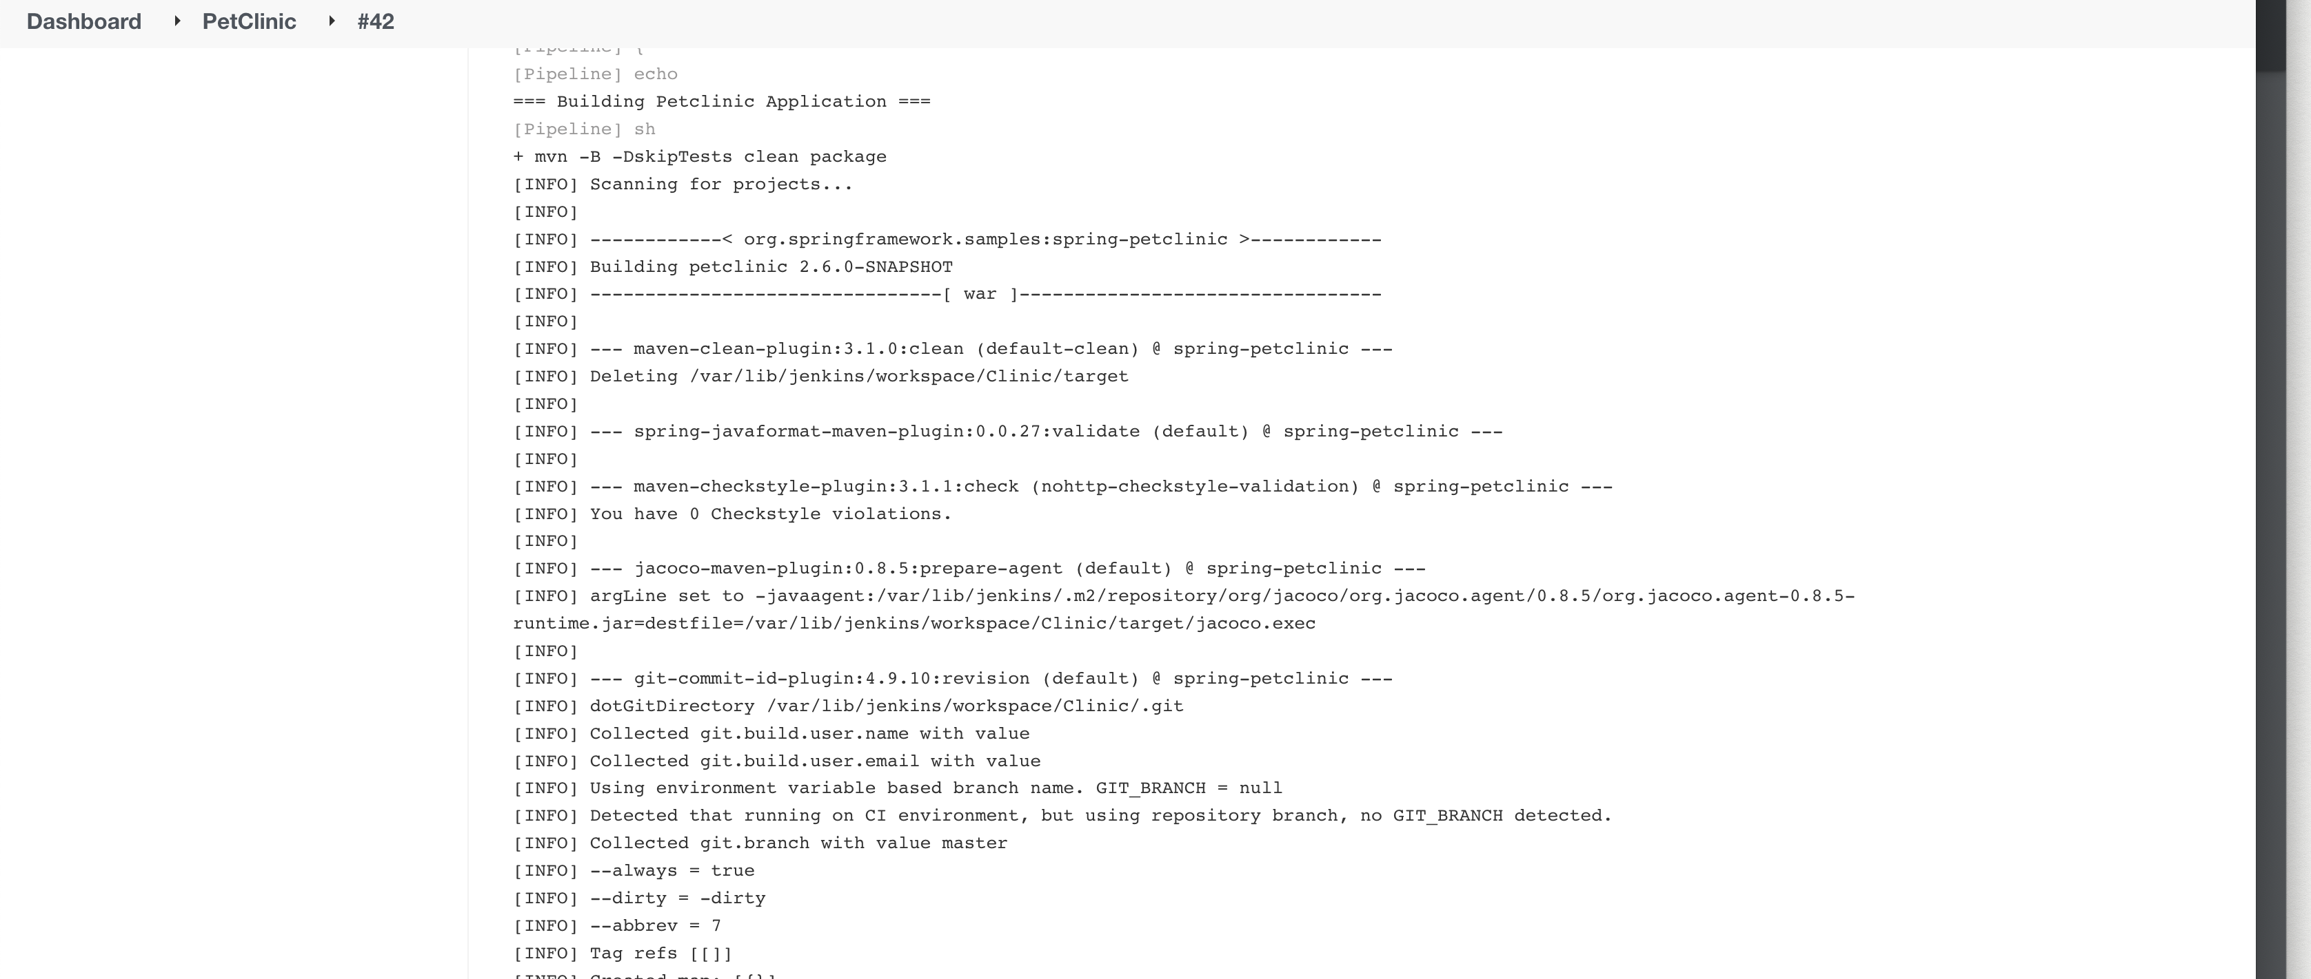

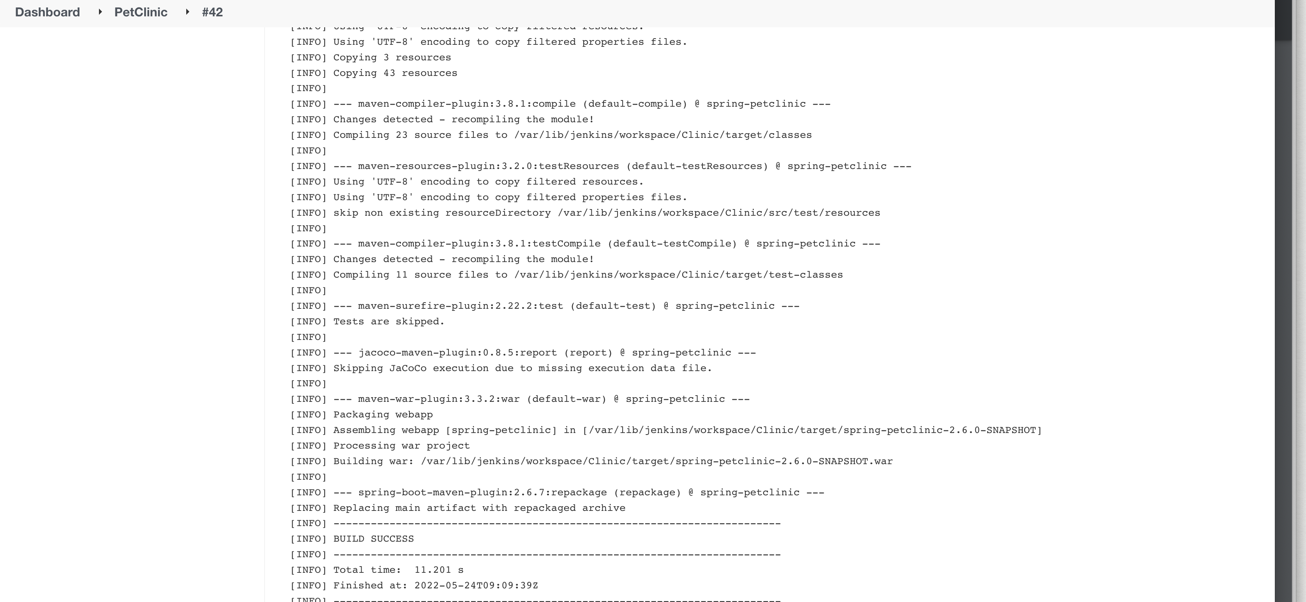

Maven test

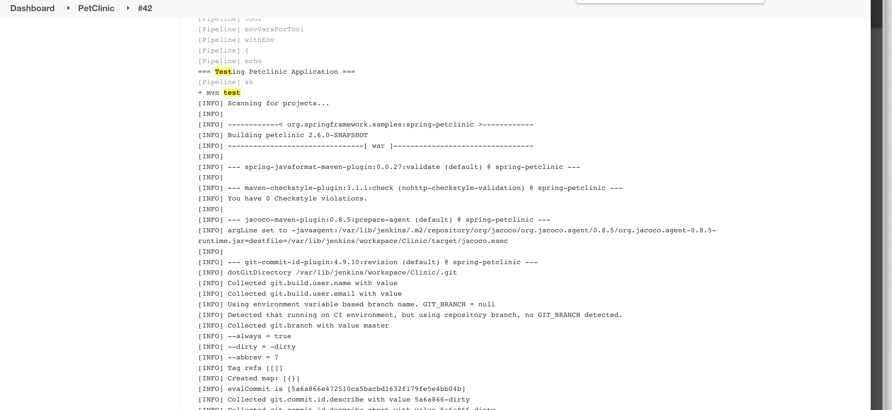

Maven Performance test

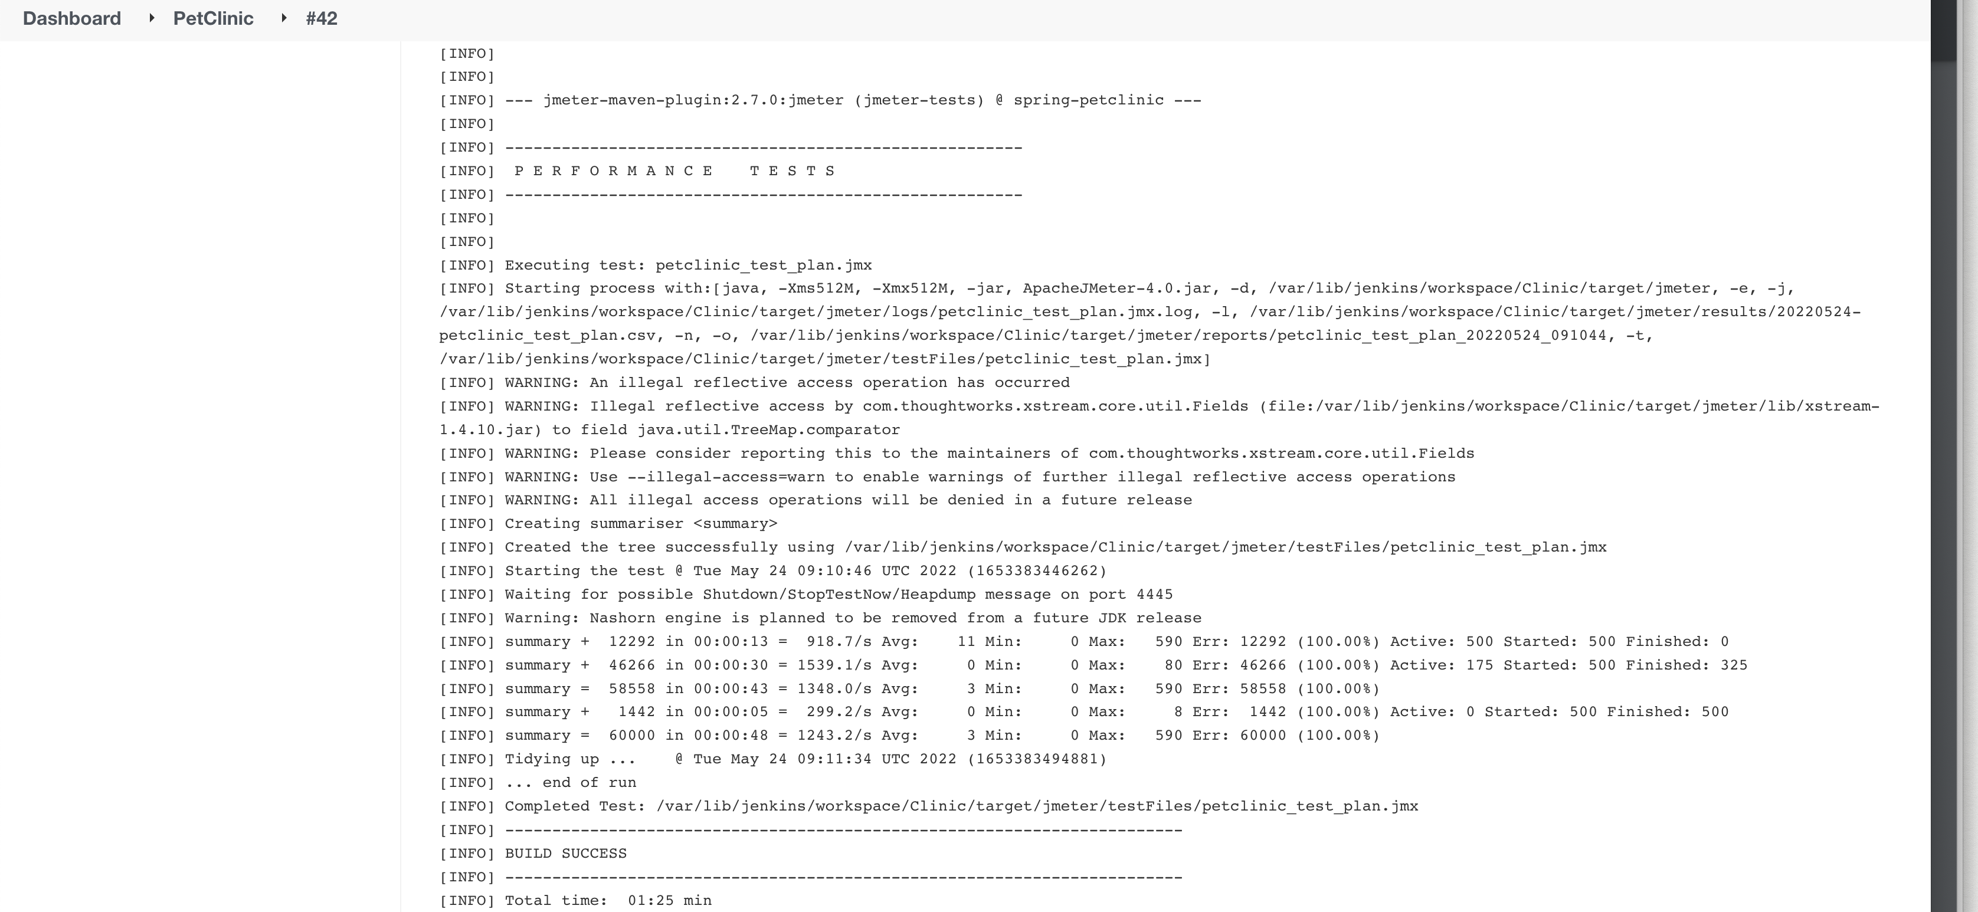

Docker Build

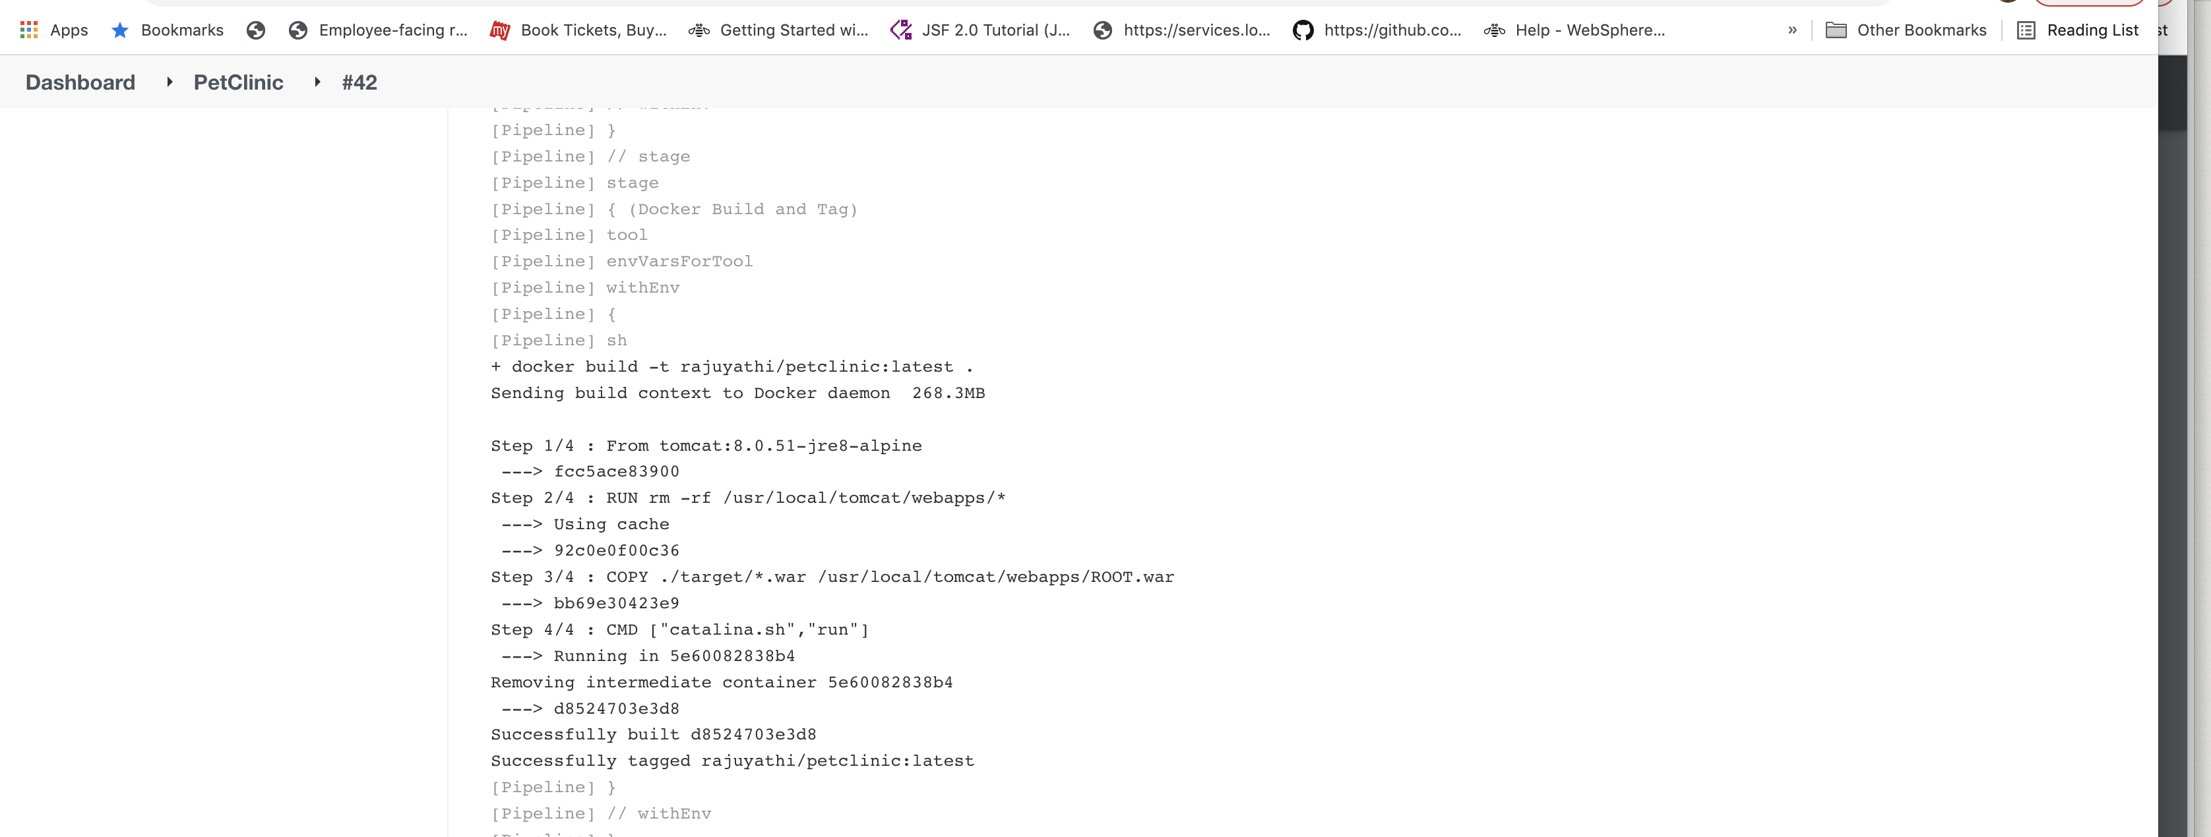

Docker push

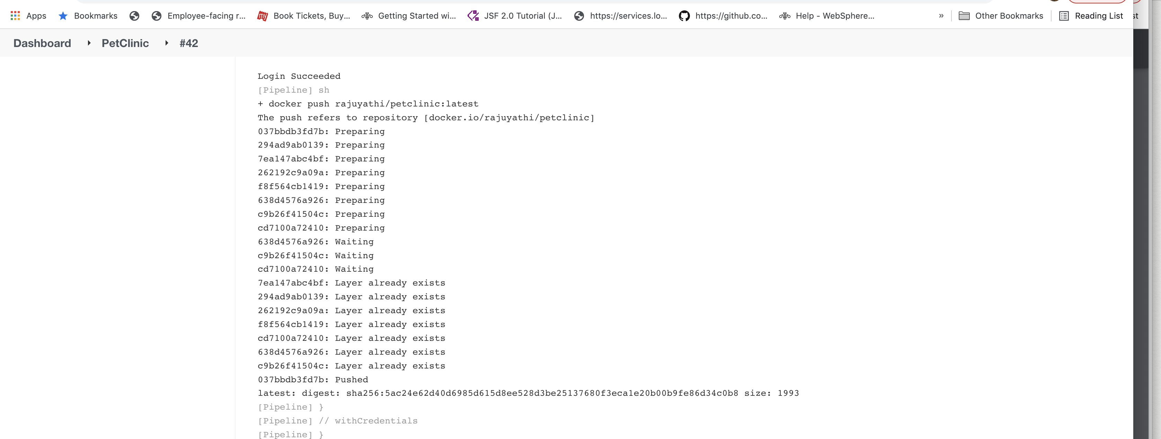

Docker Deployment

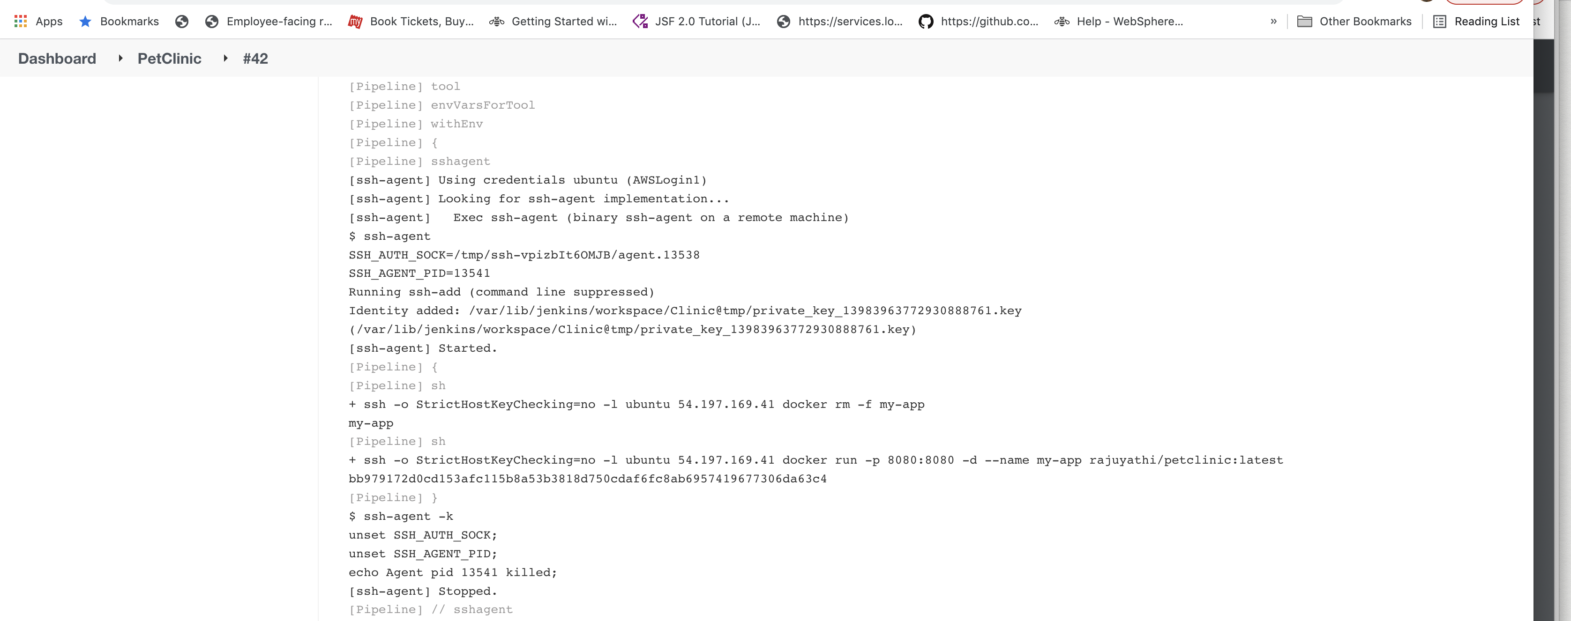

Application output

